

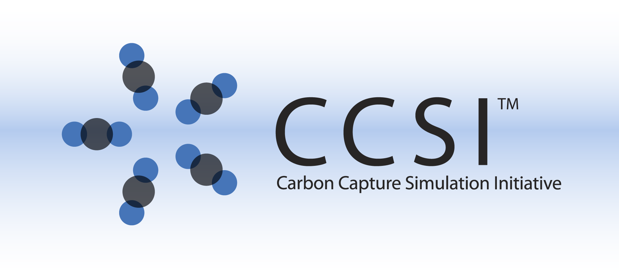

VOF Area Correlation

User Manual

Version 2.0.0

March 2018



Copyright (c) 2012 - 2018

**Copyright Notice**

VOF Area Correlation was produced under the DOE Carbon Capture Simulation Initiative (CCSI), and is copyright (c) 2012 - 2018 by the software owners: Oak Ridge Institute for Science and Education (ORISE), Los Alamos National Security, LLC., Lawrence Livermore National Security, LLC., The Regents of the University of California, through Lawrence Berkeley National Laboratory, Battelle Memorial Institute, Pacific Northwest Division through Pacific Northwest National Laboratory, Carnegie Mellon University, West Virginia University, Boston University, the Trustees of Princeton University, The University of Texas at Austin, URS Energy & Construction, Inc., et al.. All rights reserved.

NOTICE. This Software was developed under funding from the U.S. Department of Energy and the U.S. Government consequently retains certain rights. As such, the U.S. Government has been granted for itself and others acting on its behalf a paid-up, nonexclusive, irrevocable, worldwide license in the Software to reproduce, distribute copies to the public, prepare derivative works, and perform publicly and display publicly, and to permit other to do so.

**License Agreement**

VOF Area Correlation Copyright (c) 2012 - 2018, by the software owners: Oak Ridge Institute for Science and Education (ORISE), Los Alamos National Security, LLC., Lawrence Livermore National Security, LLC., The Regents of the University of California, through Lawrence Berkeley National Laboratory, Battelle Memorial Institute, Pacific Northwest Division through Pacific Northwest National Laboratory, Carnegie Mellon University, West Virginia University, Boston University, the Trustees of Princeton University, The University of Texas at Austin, URS Energy & Construction, Inc., et al. All rights reserved.

Redistribution and use in source and binary forms, with or without modification, are permitted provided that the following conditions are met:

1. Redistributions of source code must retain the above copyright notice, this list of conditions and the following disclaimer.
2. Redistributions in binary form must reproduce the above copyright notice, this list of conditions and the following disclaimer in the documentation and/or other materials provided with the distribution.
3. Neither the name of the Carbon Capture Simulation Initiative, U.S. Dept. of Energy, the National Energy Technology Laboratory, Oak Ridge Institute for Science and Education (ORISE), Los Alamos National Security, LLC., Lawrence Livermore National Security, LLC., the University of California, Lawrence Berkeley National Laboratory, Battelle Memorial Institute, Pacific Northwest National Laboratory, Carnegie Mellon University, West Virginia University, Boston University, the Trustees of Princeton University, the University of Texas at Austin, URS Energy & Construction, Inc., nor the names of its contributors may be used to endorse or promote products derived from this software without specific prior written permission.

THIS SOFTWARE IS PROVIDED BY THE COPYRIGHT HOLDERS AND CONTRIBUTORS "AS IS" AND ANY EXPRESS OR IMPLIED WARRANTIES, INCLUDING, BUT NOT LIMITED TO, THE IMPLIED WARRANTIES OF MERCHANTABILITY AND FITNESS FOR A PARTICULAR PURPOSE ARE DISCLAIMED. IN NO EVENT SHALL THE COPYRIGHT OWNER OR CONTRIBUTORS BE LIABLE FOR ANY DIRECT, INDIRECT, INCIDENTAL, SPECIAL, EXEMPLARY, OR CONSEQUENTIAL DAMAGES (INCLUDING, BUT NOT LIMITED TO, PROCUREMENT OF SUBSTITUTE GOODS OR SERVICES; LOSS OF USE, DATA, OR PROFITS; OR BUSINESS INTERRUPTION) HOWEVER CAUSED AND ON ANY THEORY OF LIABILITY, WHETHER IN CONTRACT, STRICT LIABILITY, OR TORT (INCLUDING NEGLIGENCE OR OTHERWISE) ARISING IN ANY WAY OUT OF THE USE OF THIS SOFTWARE, EVEN IF ADVISED OF THE POSSIBILITY OF SUCH DAMAGE.

You are under no obligation whatsoever to provide any bug fixes, patches, or upgrades to the features, functionality or performance of the source code ("Enhancements") to anyone; however, if you choose to make your Enhancements available either publicly, or directly to Lawrence Berkeley National Laboratory, without imposing a separate written license agreement for such Enhancements, then you hereby grant the following license: a non-exclusive, royalty-free perpetual license to install, use, modify, prepare derivative works, incorporate into other computer software, distribute, and sublicense such enhancements or derivative works thereof, in binary and source code form. This material was produced under the DOE Carbon Capture Simulation

Table of Contents

Simulating Liquid Film Flow over an Inclined Plate 5

1.0 Introduction 5

2.0 Fluent Simulation Case Study 5

2.1 Basic Problem Description 5

2.2 Simulation Overview and Prerequisites 6

2.3 Simulation Setup 7

2.4 Simulation Post-Processing 23

3.0 OpenFOAM Simulation Case Study 33

3.1 Simulation Overview and Prerequisites 33

3.2 Simulation Setup 33

4.0 References 33

List of Figures

Figure 1: Schematic of the computational flow domain –liquid flows down from top of the inclined smooth plate. 6

Figure 2: GUI components. 7

Figure 3: Dialog box for reading a case file (*.cas). 8

Figure 4: Graphic window with mesh displayed. 8

Figure 5: Materials window. 9

Figure 6: Phases window. 10

Figure 7: Cell Zone Conditions window. 11

Figure 8: Boundary Conditions bottom window. 12

Figure 9: Boundary Conditions Inlet Mixture window. 13

Figure 10: Boundary Conditions Inlet Solvent window. 13

Figure 11: Solution Controls window. 14

Figure 12: Residual Monitor window. 15

Figure 13: Surface Monitor window. 16

Figure 14: Solution Initialization Hybrid window. 17

Figure 15: Solution Initialization Adapt Region window. 18

Figure 16: Solution Initialization Patch window. 19

Figure 17: Autosave window. 20

Figure 18: Run Calculation window. 21

Figure 19: Run Calculation Calculate window. 22

Figure 20: Graphics and Animations Contours window. 24

Figure 21: Graphics and Animations Contours Mesh Display window. 25

Figure 22: Graphics and Animations Bottom Wall and Contour window. 26

Figure 23: Graphics and Animations Contours Solvent window. 27

Figure 24: Graphics and Animations Save Picture window. 28

Figure 25: Graphics and Animations Iso-Surface window. 29

Figure 26: Reports Surface Integrals window. 30

Figure 27: Reports Volume Integrals window. 31

Figure 28: Reports Surface Integrals window. 32

List of Tables

To obtain support for the products within this package, please send an e-mail to   
[ccsi-support@acceleratecarboncapture.org](mailto:ccsi-support@acceleratecarboncapture.org).

Simulating Liquid Film Flow over an Inclined Plate

1. Introduction

This document describes the simulation setup for studying liquid film flow over an inclined plate. Film flow over an inclined plate was numerically investigated using the volume of fluid (VOF) multiphase method. Flow simulations were systematically carried out for a wide range of parameters, such as varying inlet cross section, flow rate, plate inclination angle, range of solvent properties, and contact angles. Based on results of rigorous and extensive simulations, scaling theory was proposed for interfacial and wetted areas and film thickness. For more details on the background, theory, problem definition and setup, and results, please see the corresponding report available within this toolset download, of which this User Manual is included.

1. Fluent Simulation Case Study
   1. Basic Problem Description

In this user manual, film flow over an inclined plate is simulated using the commercial CFD code Ansys Fluent 14.0 [1]. The wetting behavior is then examined by post processing of the simulation results. A schematic of the simulation setup is presented in Figure 6. The domain consists of a stainless steel smooth plate with dimensions 60 mm long by 50 mm wide, and inclined at an angle of 60° with respect to the horizontal. The depth of the domain was taken as 7 mm. These are 3D gas-liquid two-phase flow simulations. In the default setting, the gas phase is defined as stagnant air at 25°C (density ρ = 1.185 kg/m3, viscosity µ = 1.831×10-5 Pa-s). The properties of the gas may be modified according to one’s requirement; however, the gas should not be made to flow without additional considerations that are not accounted for in the presented case studies. In the default setting, the liquid phase is defined as water at 25°C (ρ = 997.0 kg/m3, µ = 0.89×10-4 Pa-s). A default setting for the water flow rate is also provided, and the value depends on the particular case in question. However, the properties *and* flow of the liquid phase may be varied according to one’s needs. Regardless, the liquid phase enters the domain at the top and exits the bottom due to the presence of gravity. For further details on the computational setup and numerical formulation, the user is referred to the accompanying report.

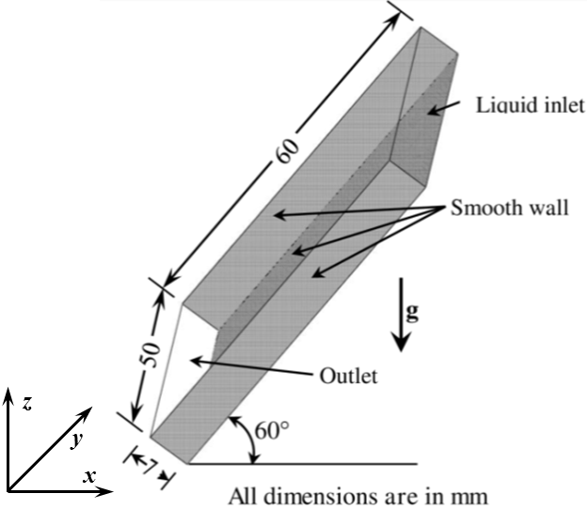

Figure : Schematic of the computational flow domain –liquid flows down from top of the inclined smooth plate.

* 1. Simulation Overview and Prerequisites

The hardware and software requirements follow that for Fluent. Since these simulations are extremely computationally intense due to the fine grid and small time steps required, all of these simulations were run in parallel on a high performance computing (HPC) system. The user is advised to contact their system administrator for an appropriate script file for running an interactive parallel Fluent job on their system.

The computational flow domain was modeled and discretized in GAMBIT, a preprocessor tool of Fluent. Proper meshing is a critical step in simulation to achieve converged and accurate results. In this context, the number of meshes in the domain was varied with 1.26-1.50M, depending on the case. The simulations were initially run on 32 cores with a time step of seconds. However, these simulations tended to diverge, indicating smaller time steps were needed. Ultimately, a typical case took around 96 hours wall time to complete.

The availability of 9 ANSYS HPC packs and 384 dedicated cores allowed for a wide ranging parametric investigation. Specifically, these resources permitted 3 cases to be run simultaneously with each parallel simulation using 128 cores. More than 250 simulations, involving different solvent properties and configurations, were run. Several new insights in the field of film flow have been achieved using the results from this investigation.

Ansys Fluent also has its own data visualization and post-processing capabilities, which is demonstrated in this manual. However, Tecplot and Ensight may also be used for post processing of the results and data visualization. Tecplot has enriched user control capabilities for CFD post processing and plot presentation. Both software packages enable excellent post processing and analysis of the simulation results and presentation of flow visualization. Regardless, users can choose other software tools for their post-processing needs.

* 1. Simulation Setup

It is assumed that users have access to Fluent on their chosen platform and know how to launch an interactive parallel Fluent session. This section briefly describes steps to run a Fluent simulation for liquid flow down an inclined plate given the appropriate Fluent case file. The case file contains the problem definition, including meshing scheme of the domain, boundary conditions, solver setting, discretization methods, and convergence criteria. The necessary case file for building the basic Fluent simulation for either rivulet flow (rivulet.cas) or for full film flow (film.cas) down an inclined plate are available in this toolset download in their respective subdirectories.

Once the user has submitted their job script, Fluent starts interactively and a new window displays on the desktop. Details can be found in the Ansys Fluent user manual; however, a snapshot of the GUI is shown below for instructive purposes. In addition to the Menu bar, the GUI is comprised of the four indicated components: navigation panel, task page, graphic window, and console (Figure 7). These terms are used in the following instructions.



Figure : GUI components.

The following tutorial walks the user through setting up and running a Fluent simulation assuming the rivulet flow case. The rivulet.cas file that is downloaded as part of this toolset, of which this User Manual is included, should be placed into the working directory. This process consists of 13 steps that primarily deal with moving through each item in the navigation panel (see above) for this case. Following this procedure and that on post processing (following section), a user is able to compute the film thickness, interfacial, and wetted areas for any solvents at any flow rates (laminar flow regime).

1. **Reading the Case File**

The case file should be read from the **Menu** bar as:

File → Read → Case

* 1. A new dialog box displays as shown in Figure 8. Select the supplied case file (rivulet.cas).
  2. Click OK to read the file.

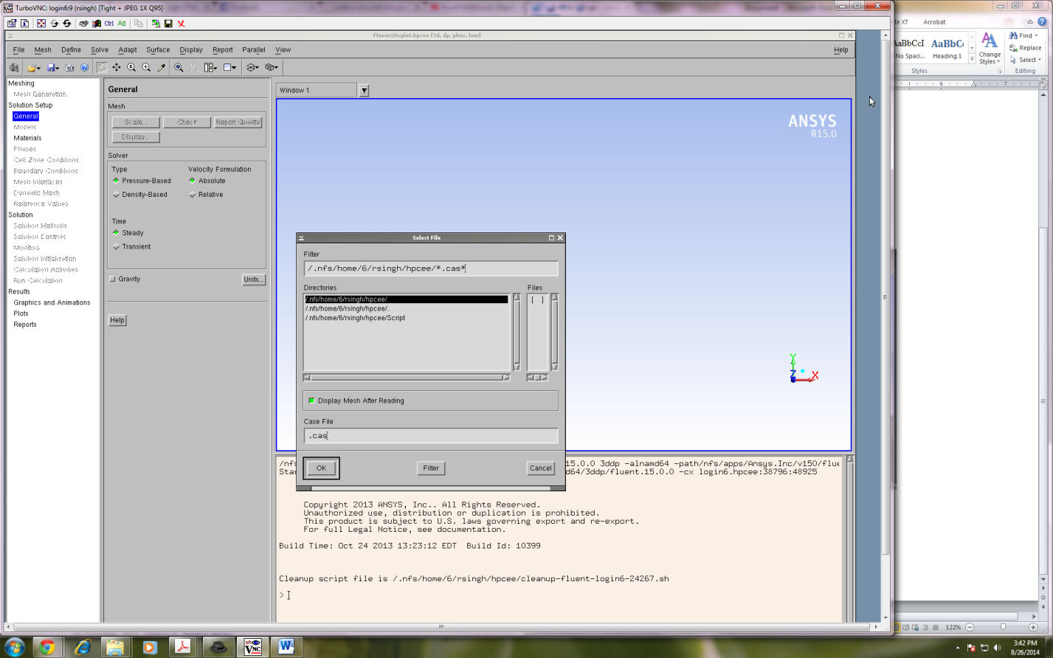

Figure : Dialog box for reading a case file (*.cas).

After reading, the mesh is displayed in the **Graphic window** (Figure 9):

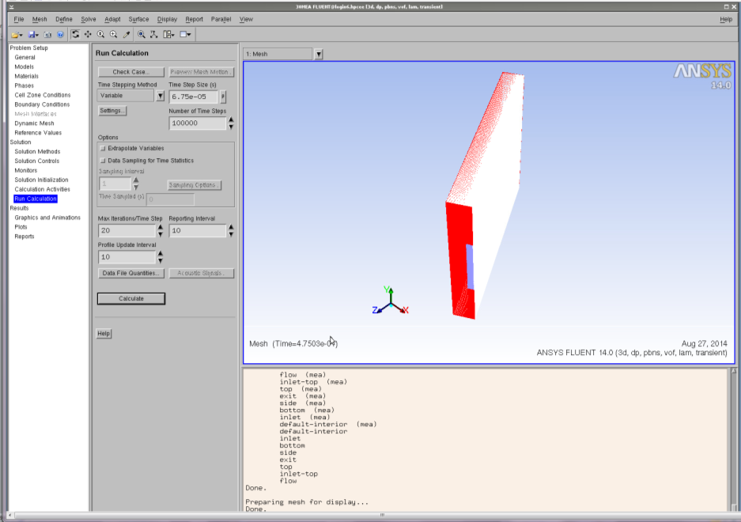

Figure : Graphic window with mesh displayed.

1. **General and Model**

No action is needed. All settings are already complete in the case file for conducting a basic volume of fluid simulation of film flow over an inclined plate. In this section, various general settings were made, including type of simulation (transient/steady), velocity formulation, gravitational effects, solver settings, etc.

1. **Material Properties**

Click **Materials** in the navigation panel and a list appears in the task page. Select the material, and a dialog box appears for defining the material (Figure 10). Here properties of the gas and solvent may be changed if desired.

Materials → Solvent → Create/Edit

* 1. Enter the name of the solvent.
  2. Enter the density.
  3. Enter the viscosity.
  4. Click Change/Create and then close the dialog box.

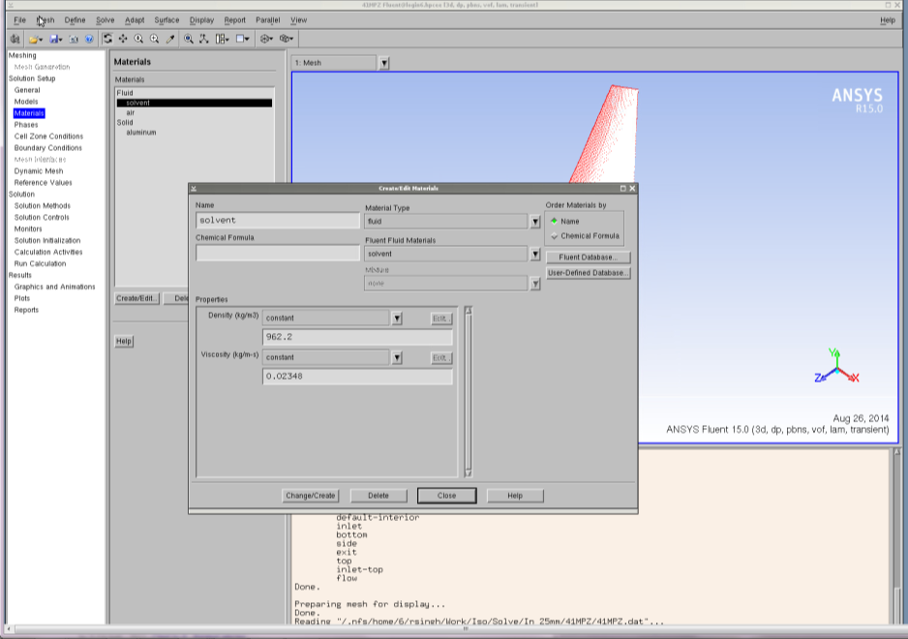

Figure : Materials window.

Materials → Gas → Create/Edit

1. Enter the density.
2. Enter the viscosity.
3. Click Change/Create and then close the dialog box.
4. **Phases**

Primary and secondary phases were already defined in the .cas file; however, the properties of the solvent and gas may have changed (Step 3). In this event, the surface tension for the interphase interaction should also be modified appropriately. To do this, click **Phases** in the navigation panel and a list of phases appear in the task page and an option for specifying the interaction. Click interaction and a dialog box appears (Figure 11).

Phases → Interaction

* 1. Click the Surface Tension tab.
  2. Select Constant from the Surface Tension drop-down and then enter the value of surface tension coefficient.
  3. Click OK to close the dialog box.

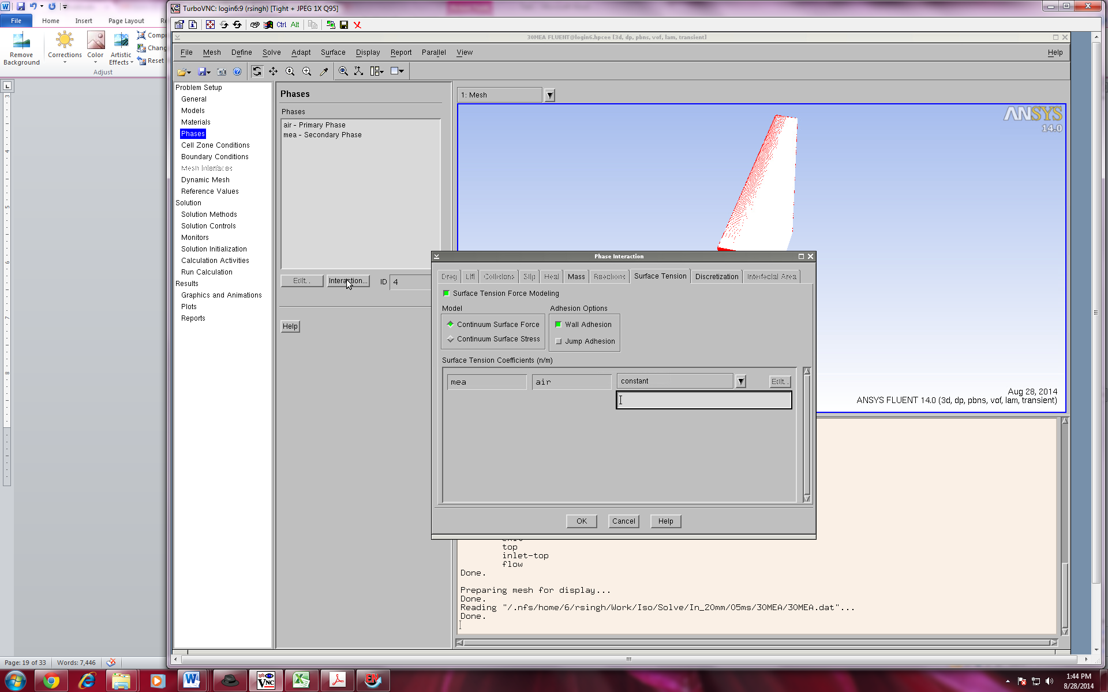

Figure : Phases window.

1. **Operating Conditions**

The operating conditions (temperature, density, and gravity) were already defined in the case file; however, the properties of the solvent and gas may have changed (Step 3). In this event, the operating density should be modified appropriately, in which the lowest value of the density among both phases should be specified as the operating density to assist in convergence. Click **Cell Zone Conditions** in the navigation panel and an option appears in the task page for the operating conditions (Figure 12). Here the user may modify the gravity and operating density.

Cell Zone Conditions → Operating Conditions

* 1. Gravity and specified operating density are already enabled, only operating density has to be changed.
  2. Specify the density of the gas as operating density.
  3. Click OK to close the dialog box.

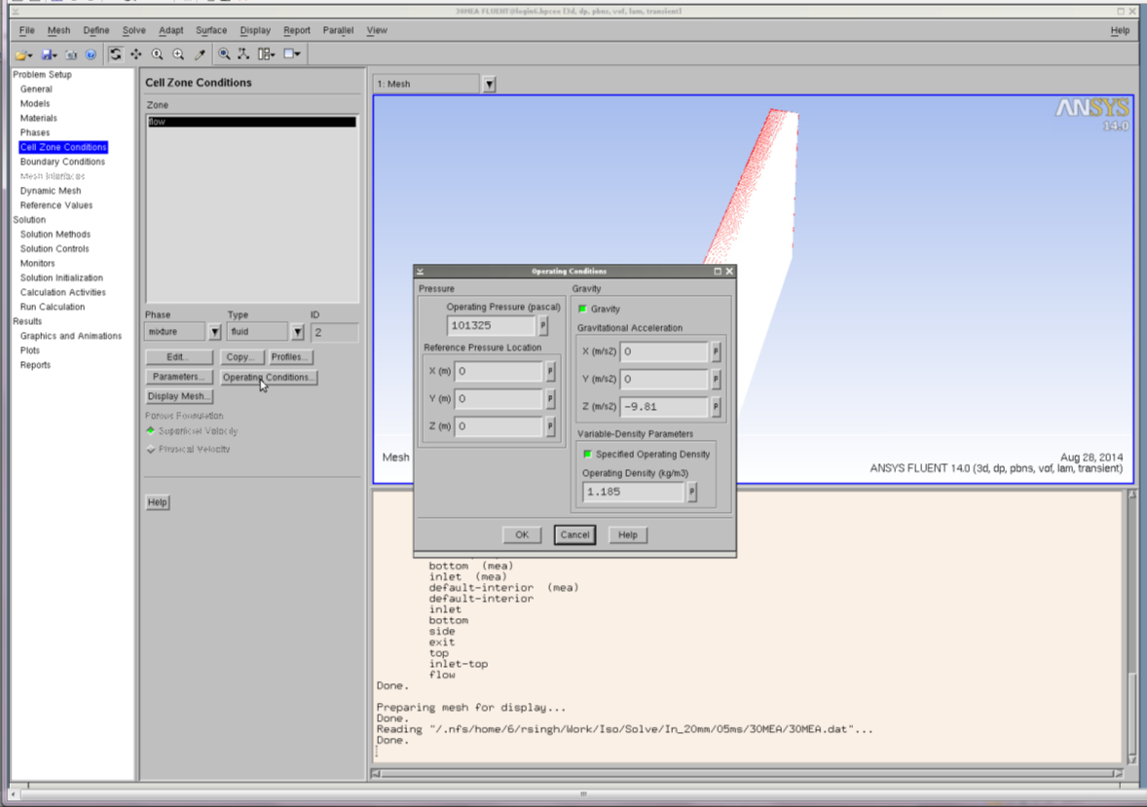

Figure : Cell Zone Conditions window.

1. **Boundary Conditions**

The boundary conditions were already defined in the case file; however, the user may adjust these accordingly. That is, the user has the option to change the value of the solvent inlet velocity, types of wall (no slip/slip), and contact angle of the solvent. The outlet boundary conditions should not be changed. Click **Boundary Conditions** in the navigation panel and a list of options appear in the task page for defining the boundary conditions (Figure 13). Here the user may modify the boundary conditions of the face associated with the wall and the inlet boundaries.

Boundary Condition → Bottom → Edit

* 1. Enter the contact angle for the wall adhesion.
  2. Select Constant in the drop-down for a static contact angle.
  3. Click OK to close the dialog box.

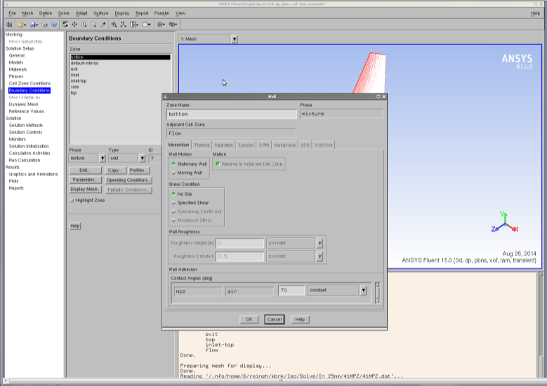

Figure : Boundary Conditions bottom window.

Boundary Condition → Side → Edit

1. Enter the contact angle for the wall adhesion.
2. Select Constant in the drop-down for a static contact angle.
3. Click OK to close the dialog box.

Boundary Condition → Inlet

1. Select Phase as mixture and then click the Edit button.
2. Specify the velocity magnitude in the dialog box (Figure 14).
3. Click OK to close the dialog box.

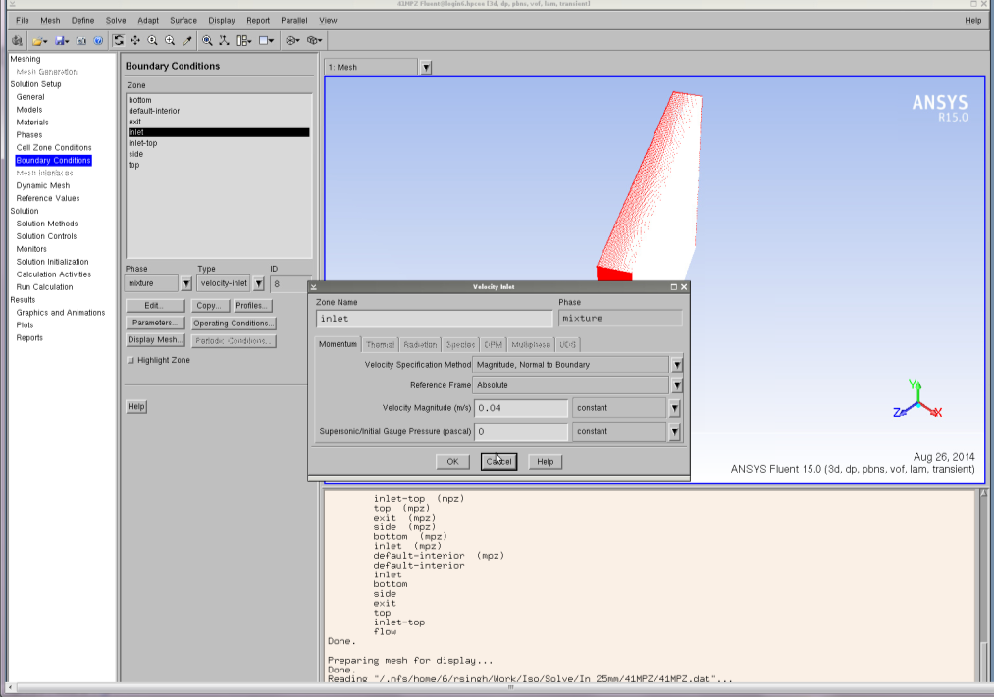

Figure : Boundary Conditions Inlet Mixture window.

Boundary Condition → Inlet

1. Select Phase as solvent and then click the Edit button.
2. Specify 1 in the Volume Fraction in the dialog box (Figure 15).
3. Click OK to close the dialog box.

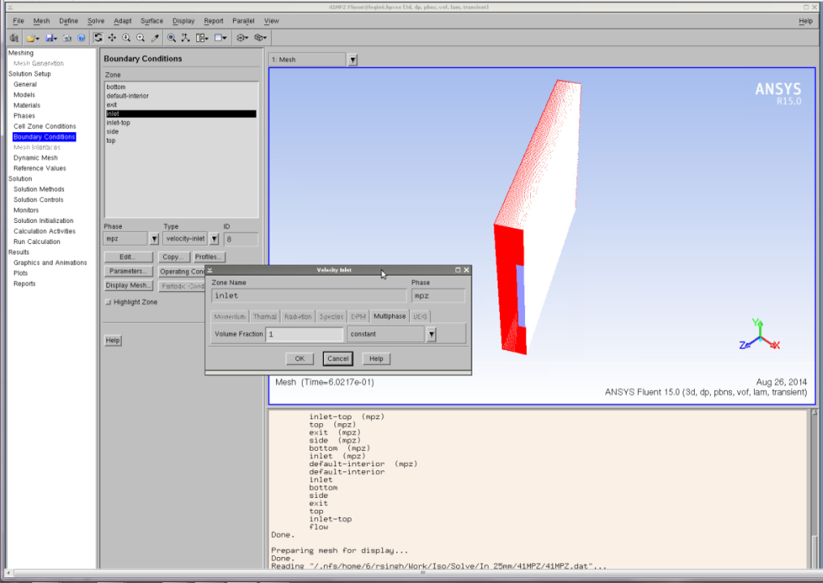

Figure 10: Boundary Conditions Inlet Solvent window.

1. **Solution Method and Solution Control**

No action is needed. All settings are already done in the case file. In this section, the spatial discretization scheme of all the transport equations, the transient formulation, and the   
pressure-velocity coupling were specified (Figure 16).

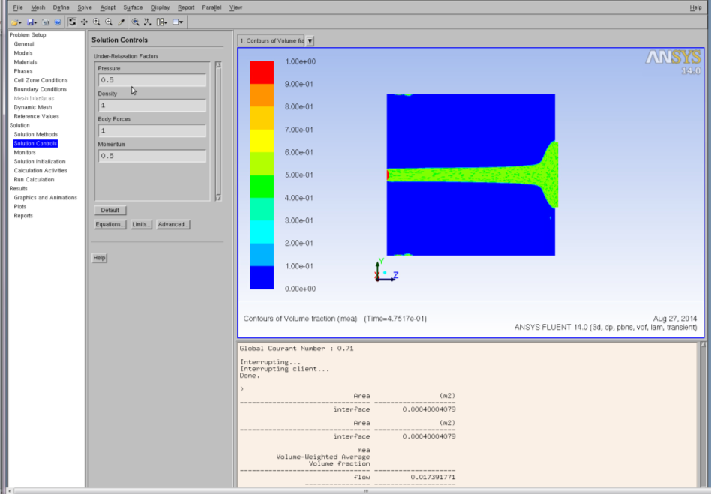

Figure : Solution Controls window.

1. **Solution Monitor**

All settings are already done in the case file; however, the user will need to change the directory path for each of the generated out files. In this section, monitoring of the convergence of the solutions by residual, mass flow rate, and wetted area were set up (Figure 17). In this study, a simulation is assumed to be converged when the mass flow at the exit and wetted area of the plate is constant.

* 1. Residual monitor is predefined. No action is needed.

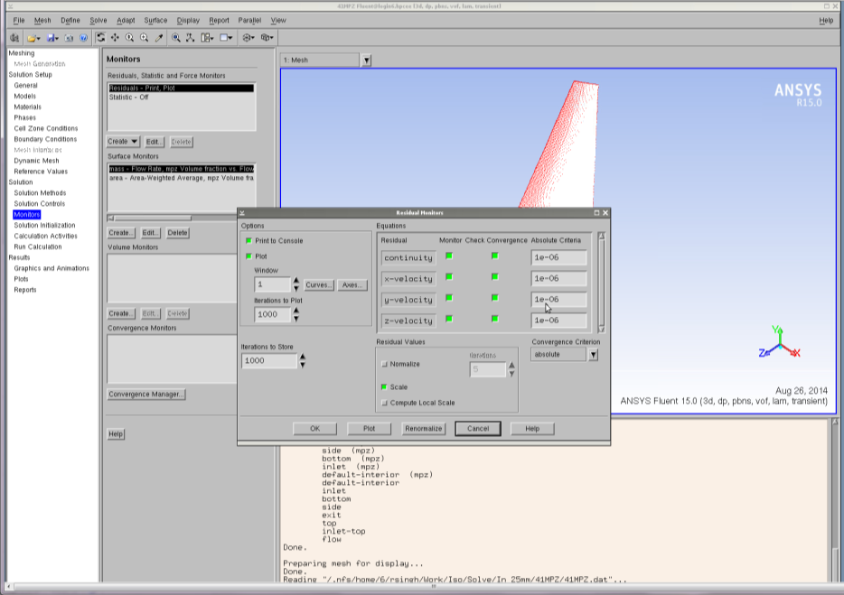

Figure : Residual Monitor window.

* 1. Surface monitor is predefined.

Here, a surface monitor is defined to track the solvent mass flow rate at the exit to ensure a converged solution. Change the directory path of the generated out file in the box higlighted by red in Figure 18. An additional surface monitor is also defined for the wetted area of the plate (Figure 18). As before, the directory path of the generated out file must be changed. When both quantities achieve steady value, the solution is considered to be converged.



Figure : Surface Monitor window.

* 1. Volume monitor is predefined.

This enables calculation for liquid holdup. Change the directory path for the generated out file.

1. **Initialize the Solution**

Click **Solution Initialization** in the navigation panel and an option for the initialization method displays. Select hybrid initialization and click initialize (Figure 19). Here the flow variables need to be defined so the flow field is initialized to these values.

Solution Initialize → Hybrid Initialization → Initialize

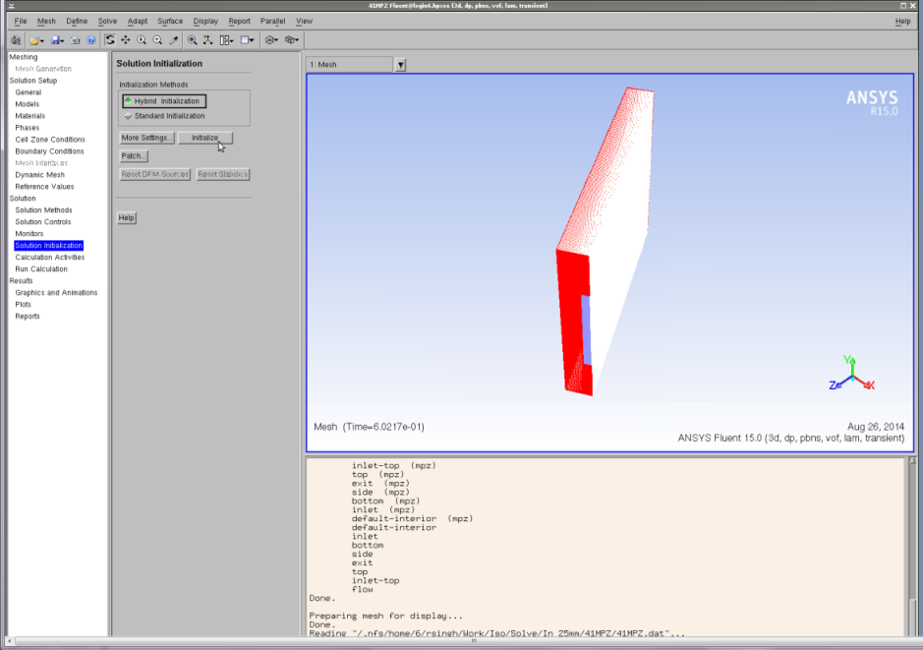

Figure 14: Solution Initialization Hybrid window.

1. **Patch the Domain**

In this section, the phase(s) that are present in the domain at the start of the simulation are specified. To define an initially dry plate, the user must specify air as the only phase present in the domain. Navigate to the **Menu** bar, select **Adapt**, and then a number of options appear in the drop-down. Select **Region** and a new dialog box appears (Figure 20).

Adapt → Region

* 1. Select the initial condition region by specifying the minimum and maximum coordinates of the flow domain; it is predefined in the case file.
  2. Click Mark button.
  3. Click Close to close the dialog box.

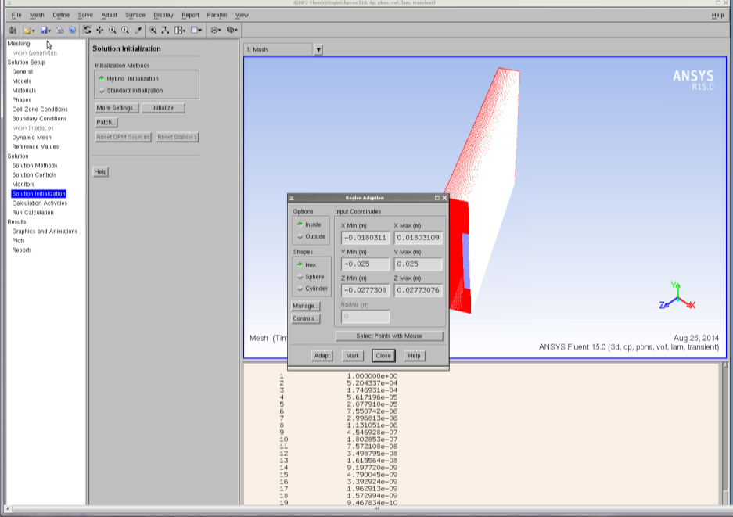

Figure : Solution Initialization Adapt Region window.

Solution Initialization → Patch

1. The Patch dialog box appears (Figure 21).
2. Scroll Phase drop-down and then select Solvent.
3. Select Volume Fraction.
4. Specify 0 in the Value (for initially dry plate).
5. Select the Register Patch.
6. Click Patch button.
7. Click Close button to close the dialog box.

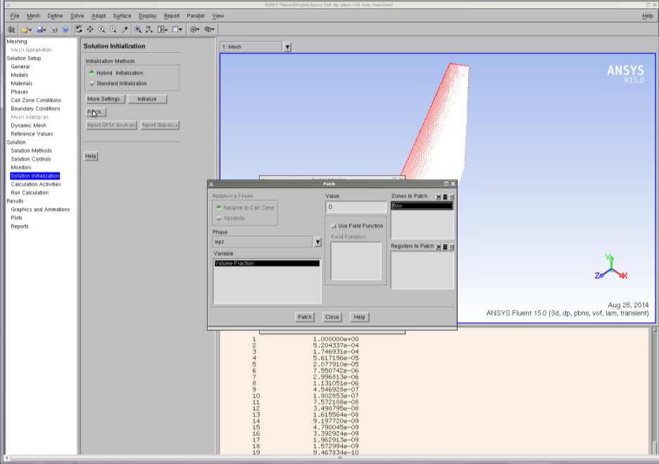

Figure : Solution Initialization Patch window.

1. **Autosave**

The autosave option saves the cas/data files automatically at a defined interval. If the job crashes, the user may restart the job with the latest saved file, otherwise, the simulation needs to be started from the beginning. The settings governing the autosave feature need to be set (Figure 22).

Calculation Activity → Autosave (Every) → Edit

* 1. Autosave dialog box displays.
  2. Enter number of time steps for auto save.
  3. Click each time.
  4. Click to retain only the most recent files. Specify the maximum number of data files.
  5. Specify the path and name of the file for autosave.
  6. Click OK to close the dialog box.

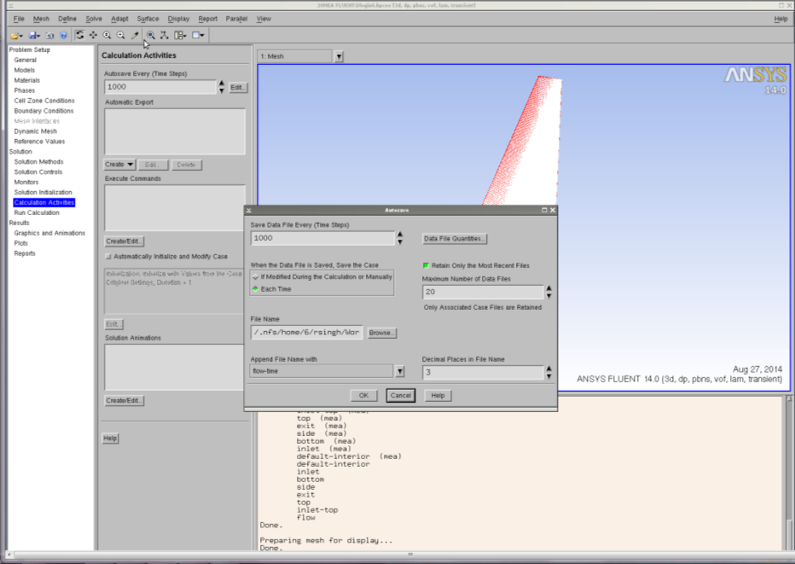

Figure : Autosave window.

1. **Starting the Simulation**

In this final step, the simulation is started. Click **Run Calculation** in the navigation panel and a list of run options appear in the task page (Figure 23). All quantities governing the time step have already been defined according to the case file, which uses a variable time stepping method. However, the interested user may modify these by clicking the options under Settings.

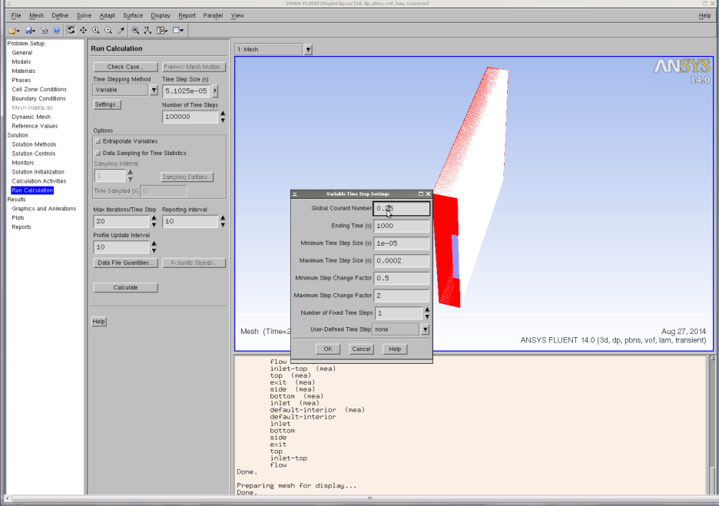

Figure : Run Calculation window.

Otherwise the final steps to running the simulation are as follows.

Run Calculation → Calculate

* 1. Specify the starting time step. After one time step, the time step size is automatically calculated.
  2. Specify the maximum iteration per time step.
  3. Specify the profile update interval.
  4. Specify the reporting interval.
  5. Click the button Calculate to start the simulation (Figure 24).
  6. Simulation starts.

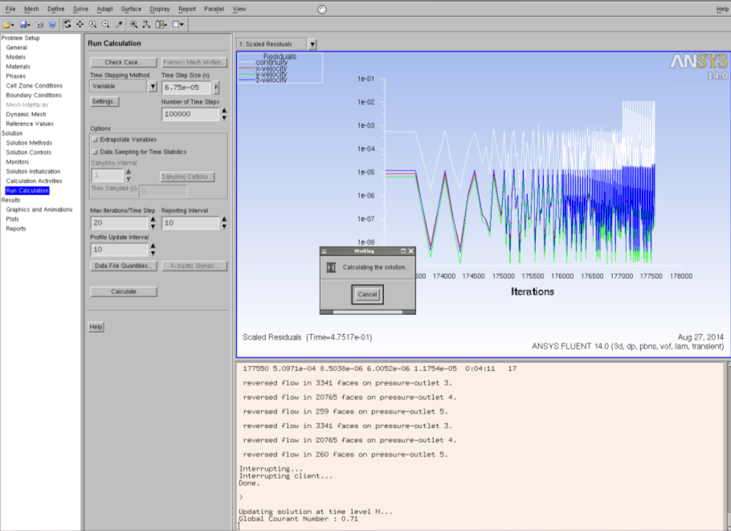

Figure : Run Calculation Calculate window.

Similarly, the surface monitor also appears in the graphic window. To look at the surface and volume monitor, scroll down the window drop-down and select the window for each monitor.

1. **Saving the Simulation**

The simulation is considered to be complete when the wetted area of the plate and mass flow rate of the solvent at the exit achieve steady value. Once the steady value is achieved, the simulation can be interrupted by clicking the **Cancel** button on the **working** dialog box in the graphic window. Once the simulation is interrupted, the following lines appear on the console:

Interrupting client…  
Done.

The case/dat file can now be saved for post processing and future use. From the **Menu** bar:

File → Write → Case & Data

A new dialog box displays.

* 1. Specify the name of Case/Data file box.
  2. Click OK button to save the Case/Data file.
  3. Simulation Post-Processing

Following successful launch and completion of the simulation, the users may examine any number of quantities, such as pressure or phase velocity. The user may also wish to calculate the film thickness, wetted area, area of the interface, and shape of the interface per scope of the problem. In the following section, the method to compute and plot these quantities is explained. Recall that in the VOF computation, a volume fraction of any phase of 0.50 represents the interface between phases.

1. **Tracking the Interface**

Navigate to the navigation panel, select **Graphics and Animations**, and then a number of options appear in the task page. From the task page select **Contours**.

Graphic and Animation → Contours → Set Up

The Contours dialog box displays (Figure 25).

* 1. Select Phase in the Contours drop-down.
  2. Select Solvent as phase drop-down.
  3. Activate the Clip to range option and uncheck the Auto range.
  4. Specify 0.5 as minimum and 1 as maximum value.
  5. Select Default Interior in the surface box.
  6. Click Display, and Contours appears in the graphic window.
  7. Click Close button to close the window.

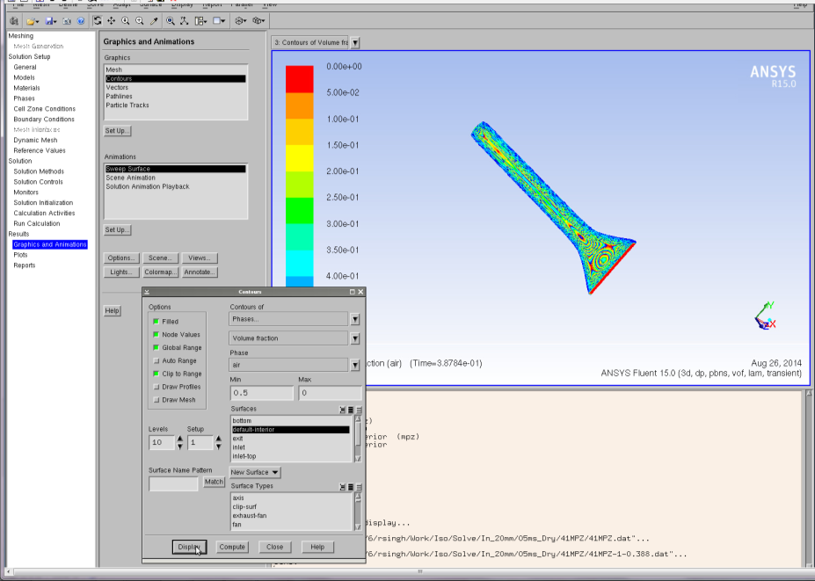

Figure : Graphics and Animations Contours window.

1. **Interface with Plate**

Navigate to the navigation panel, select **Graphics and Animations**, and then a number of options appear in the task page. From the task page select **Contours**.

Graphic and Animation → Contours

The Contour dialog box displays.

* 1. Select Phase in the Contours drop-down.
  2. Select Solvent as Phase drop-down.
  3. Activate the Clip to Range option.
  4. Specify 0.5 as minimum and 1 as maximum value.
  5. Activate the Draw Mesh.
  6. A new dialog box of mesh display opens (Figure 26).
  7. Select Bottom on the surface list.
  8. Click Display and mesh of the bottom displays.

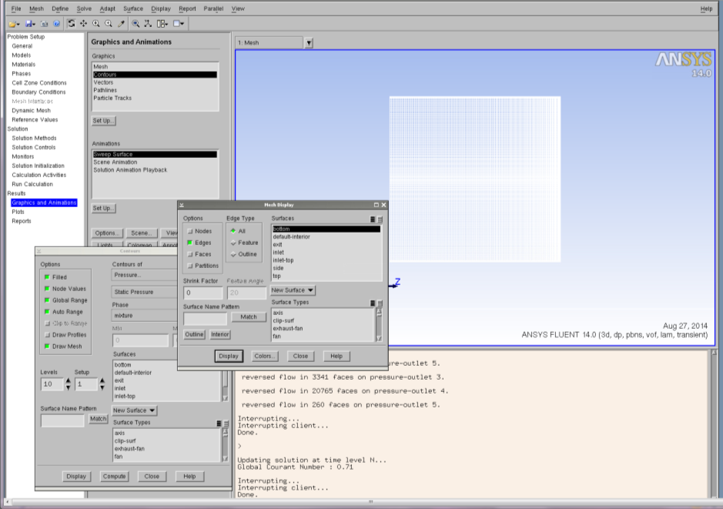

Figure : Graphics and Animations Contours Mesh Display window.

* 1. Click Close to close the window.
  2. Select Default Interior in the surface box.
  3. The Contour dialog box exists; click Display.
  4. Bottom wall and Contour appear in the graphic window (Figure 27).
  5. Click Close button to close the window.

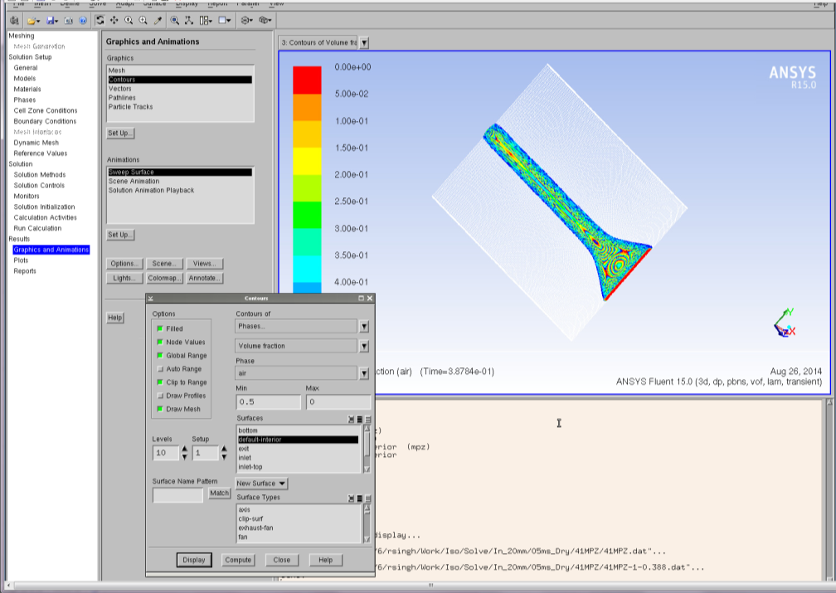

Figure : Graphics and Animations Bottom Wall and Contour window.

1. **Wetted Area of the Plate**

Navigate to the navigation panel, select **Graphics and Animations**, and then a number of options appear in the task page. From the task page select **Contours**.

Graphic and Animation → Contours

The Contour dialog box displays.

* 1. Select Phase in the Contours drop-down.
  2. Select Solvent as phase drop-down.
  3. Activate the Clip of Auto Ranges.
  4. Select Bottom in the surface box.
  5. Clear the Draw Mesh check box if already selected.
  6. Click Display, and Contours appears in the graphic window (Figure 28).
  7. Click Close button to close the window.

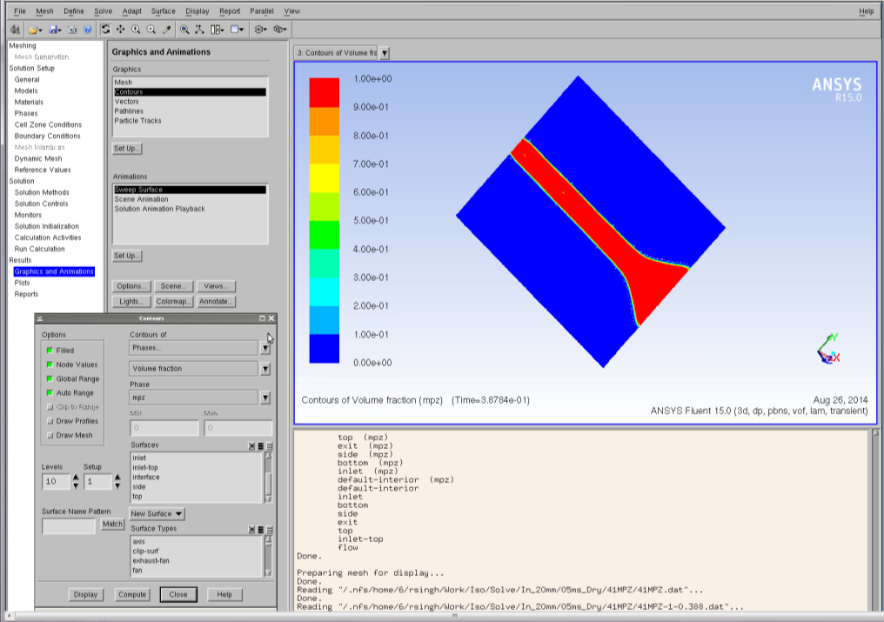

Figure : Graphics and Animations Contours Solvent window.

1. **Saving a Snapshot**

To save an image displayed in the graphic window for future use, navigate to the **Menu bar** and select **File**. A number of options appear in the drop-down. From the drop-down, select **Save Picture**, and a dialog box for saving the picture appears (Figure 29).

File → Save Picture

* 1. Select file format (ps/eps/png/jpeg/tiff).
  2. Select Save button.
  3. A new dialog box appears; write the file name.
  4. Close the dialog box.

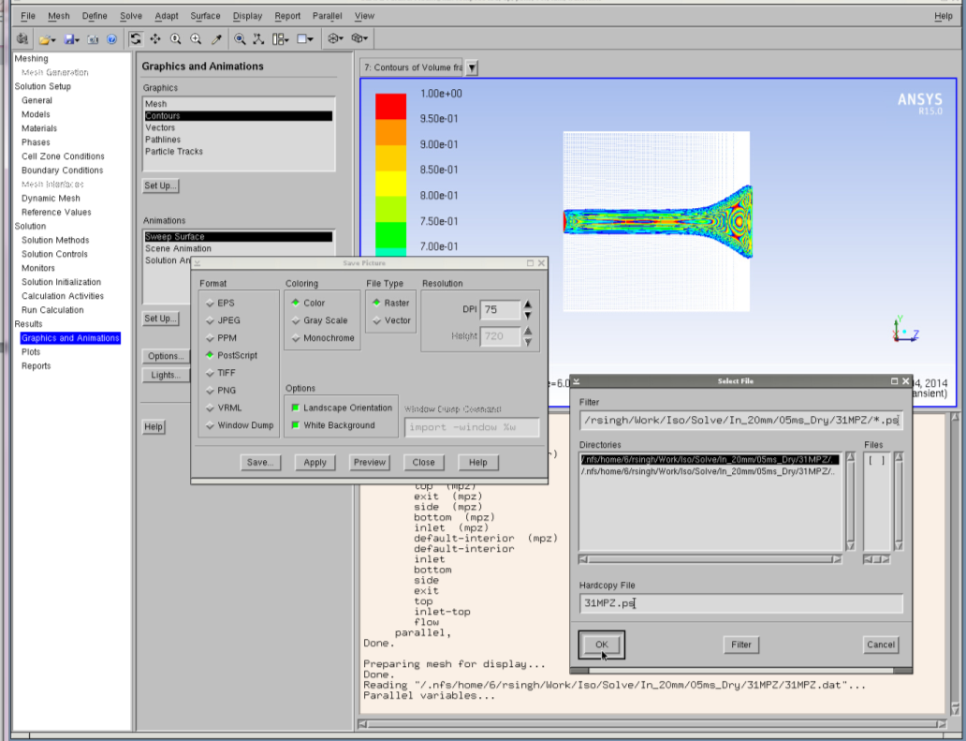

Figure : Graphics and Animations Save Picture window.

1. **Creating an Interface**

Navigate to the **Menu** bar, select **Surface**, and then a number of options appear in the drop-down. From the drop-down, select **Iso-surface**. Here an iso-surface representing the interface is defined (Figure 30).

Surface → Iso-Surface

The Iso Surface dialog box appears.

* 1. Select Phase in the surface constant drop-down.
  2. Select Solvent in the phase drop-down.
  3. Specify 0.50 as iso value.
  4. Select Flow in zone.
  5. Specify Interface as surface name.
  6. Click Create button to generate Iso surface.
  7. Click Close button to close the dialog box.

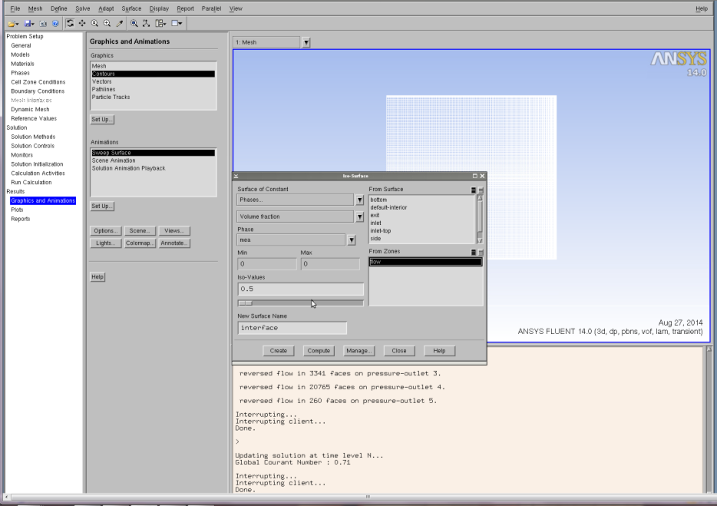

Figure : Graphics and Animations Iso-Surface window.

1. **Area of the Interface**

Navigate to the navigation panel, select **Reports**, and then a number of options appear in the task page. From the task page, select **Surface Integrals**,and click Setup. Here an iso-surface representing the surface is defined (Figure 31).

Report → Surface Integrals → Setup

The Surface Integral dialog box appears.

* 1. Select Area in the report type drop-down.
  2. Select Interface to Surface box.
  3. Click Compute to calculate the area of the interface. The computed value of the area appears in the dialog box, as well as in the console.
  4. This value can also be saved in the file by clicking the Save Output Parameter.

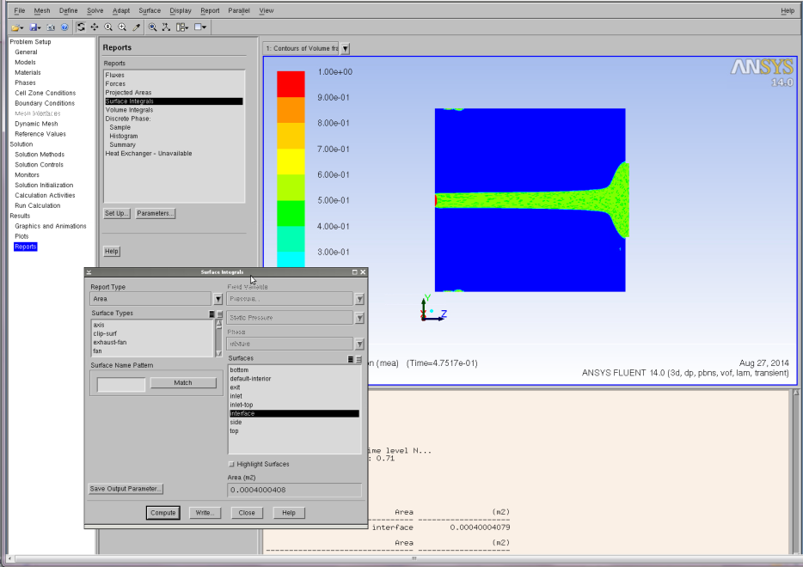

Figure : Reports Surface Integrals window.

1. **Liquid Holdup**

Report → Volume Integrals → Setup

The Volume Integral dialog box appears (Figure 32).

1. Activate the Volume-Average check boxes.
2. Select Phases in the Field Variable drop-down.
3. Select Solvent in the Phase drop-down.
4. Select Flow in the Cell Zones.
5. Click Compute to calculate the liquid holdup. The computed value of the holdup displays in the dialog box, as well as in the console.
6. This value can also be saved in the file by clicking the Save Output Parameter.

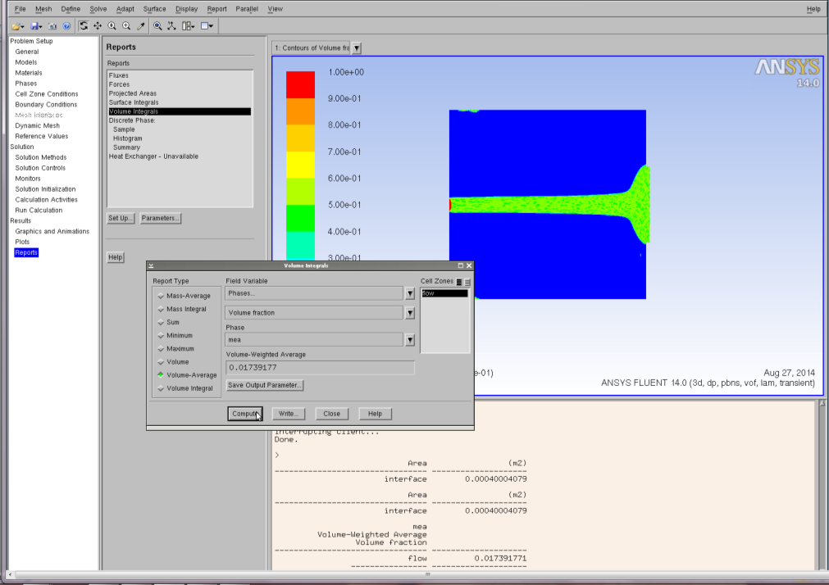

Figure : Reports Volume Integrals window.

1. **Film Thickness**

The above steps have been viewed in the context of rivulet flow. The measurement of film thickness was performed for the case of full film flow. Therefore, the user must load the appropriate .cas file (film.cas) and follow the procedure outlined for running such a Fluent simulation. As noted earlier, this file is available in this toolset download, of which this User Manual is included. Once the simulation has been run, the user may perform the steps outlined here for calculating film thickness.

Reports → Surface Integrals → Setup

The Surface Integral dialog box appears (Figure 33).

* 1. Select Integral in the report type drop-down.
  2. Select Custom field functions for field variable.
  3. Select Film-Thickness in the Next Bottom box.
  4. Select Plane-Film in the Surface box.
  5. Click Compute to calculate film thickness. The unit of the computed film thickness value is mm.
  6. This value can also be saved in the file by clicking the Save Output Parameters.

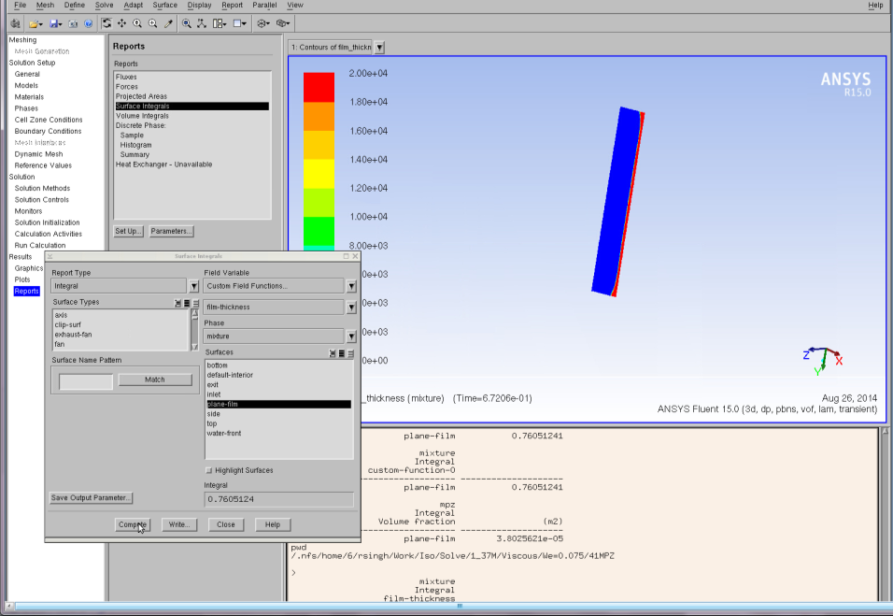

Figure : Reports Surface Integrals window.

1. OpenFOAM Simulation Case Study
   1. Simulation Overview and Prerequisites

A subset of the Fluent simulations were also conducted using OpenFOAM [2]. Thus, the general problem setup is identical to that in Fluent consisting of three dimensional gas-liquid two phase flow down an inclined plate. The problem dimensions and physical properties of the phases are as before.

* 1. Simulation Setup

It is assumed that the users have access to OpenFOAM on their chosen platform. For details on installation of OpenFOAM, refer to <http://www.openfoam.org/download/>. For information on the file structure of OpenFOAM, please see the following link <http://www.openfoam.org/docs/user/case-file-structure.php#x17-930004.1>. This link explains the file structure for geometries, physical parameters, initial conditions, etc. Finally, the following link is a Volume of Fluid module tutorial of OpenFOAM <http://www.openfoam.org/docs/user/damBreak.php>.

The necessary files for building the basic OpenFOAM VOF simulation for rivulet flow down an inclined plate are available in this toolset download of which this User Manual is included. The available case is for water, as the other simulations may be duplicated by modifying the appropriate physical and transport properties of the fluid. The folder contains the mesh file but not the generated mesh. The latter can be generated within OpenFOAM once it is installed.

1. References

[1] ANSYS FLUENT Theory Guide. 2011.

[2] User Guide Open FOAM 2.3.0., 2014, Bracknell, UK, OpenCFD Ltd.